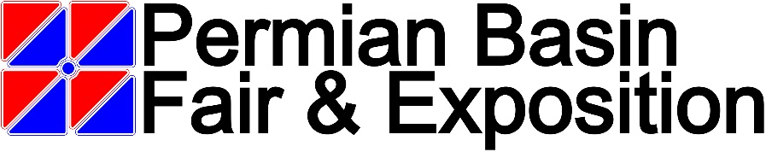
***Due to Covid-19, These rules are subject to change***

Livestock Events – Junior Lamb Rules 2022
- Livestock Events General Rules & Regulations apply to these shows.
- There will be two shows, Show A & Show B.
  - Exhibitors wishing to participate in Show B must be registered in Show A.
  - Show B will follow Show A
  - Exhibitors with multiple entries in one class refer to the General Rules and Regulations.
- Lambs must be on the grounds by 6:00 pm Saturday September 10, 2022.
  - NO LATE ARRIVALS WILL BE ACCEPTED.
- Exhibitors will weigh and turn in weights and ear tag numbers of their own lamb.
  - Lambs will not be allowed in the show ring without ear tags, existing ear tags may be used, or ear tags can be purchased for $5.00 in the Farming & Ranching Office.
  - Weights should be turned in as soon as possible.
    - 7:00 pm is the deadline for all weights.
- After Superintendent has posted the classes, the exhibitor has (1) hour to notify the office of any corrections.
- Classes will be broke equally after weights are turned in.
  - There will be a three (3) pound weigh back on the top of the class.
  - Any lamb weighing three (3) pounds over the top of the class will be disqualified.
- Show order will be as follows:
Hair Sheep
Southdown
Finewool
Finewool Cross
Medium Wool
Scholarship Award
Showmanship
- Wether & Ewe lambs may be shown together.
- Lambs are to be sheared to a uniform staple length over their entire body no to exceed 1/4 inch.
  - Exceptions, top knot and boots will be allowed.
- No Paintings of lambs will be allowed.
- All Entry Fees are non-refundable

